Source: Proceedings of the International Workshop on Smart Materials and Structures Technology, Honolulu, Hawaii, USA, January 12-14, 2004.

Embedding Actuation Functionalities in a Wireless Structural Health Monitoring System

J. P. LYNCH, A. SUNDARARAJAN, H. SOHN, G. PARK

C. FARRAR and K. H. LAW

ABSTRACT

Structural health monitoring is a broad field that encompasses a number of synergetic technologies that together can provide a system to identify and characterize possible damage present within a structure. Such a system should include data acquisition subsystems capable of recording a structure’s response to ambient and external loads. Furthermore, it is now possible to include computational hardware in system designs for local execution of embedded engineering analyses that interrogate recorded response data for indicators correlated to possible damage. This paper describes a prototype wireless actuation and sensing unit which is intended: (1) to collect measurement data from sensors embedded within structural elements that are excited by low-energy actuation elements; (2) to store, manage and locally process the measurement data collected; and (3) to communicate data and results to a structural monitoring system network.

INTRODUCTION

The professional engineering community is seeking for low-cost structural monitoring tools that can accurately determine the integrity of civil structures such as bridges, control centers and hospitals; predictions of structural performance and future operational safety is an increasingly important task. Structural monitoring involves taking measurements on a structure over a period of time, extracting features from these measurements, and analyzing these features to determine the current state of health of the structure. This requires an integrated framework that brings together synergetic hardware and software elements to create a comprehensive structural monitoring strategy. The hardware components are to sense, acquire and transmit data while the software components facilitate the processing and interpretation of the data.
_____________
Jerome P. Lynch, University of Michigan, Ann Arbor, MI 48109
Arvind Sundararajan and Kincho H. Law, Stanford University, Stanford, CA 94305
Hoon Sohn, Gyuhae Park and Charles Farrar, Los Alamos National Lab, Los Alamos, NM 87545
There has been an explosive growth of innovation in all engineering disciplines with new conduits of technology transfer between disciplines taking hold. Advanced technologies such as wireless communications, micro-mechanical solid-state sensors, and mobile computing are now being adopted in structural monitoring applications. For instance, researchers have explored the adoption of wireless communications in structural monitoring systems to reduce installation and maintenance costs [1]. Lynch, et al. has extended this work to include embedded microcontrollers within a wireless sensing unit prototype to support a decentralized monitoring framework and to allow efficient use of resources by embedding damage detection procedures in the sensor units [2,3].
In this paper, we describe the design of a wireless actuation and sensing unit that is intended to (1) collect measurement data from sensors embedded within structural elements that are excited by low-energy actuation elements, (2) store, manage and locally process the measurement data, and (3) to communicate data and results to a wireless sensing network comprised of other wireless sensing/actuation units upon demand. The design draws upon recent advances made in the fields of electronics, wireless communications, smart materials and embedded system design. Furthermore, procedures such as AR-ARX models for damage detection applications are embedded onto the sensing unit to demonstrate real time diagnostics scenarios [4].

ARCHITECTURAL DESIGN

The design of the wireless actuation and sensing unit can be divided into four major subsystems; sensor interface, actuation interface, computational core, and wireless communication channel. The interoperability of the four subsystems is described by Figure 1. The sensing interface is responsible for acquiring measurement data from various analog sensors. The computational core is designed to interrogate the data for identification of the system’s properties. The wireless communication channel is used to transmit the results to a wireless data server. The actuator interface is designed to issue command signals for “self” excitation and actuation. For the current prototype experiment, we employ piezoelectric lead-zirconate-titanate (PZT) pads epoxy mounted to structural elements as both actuation and sensing elements.
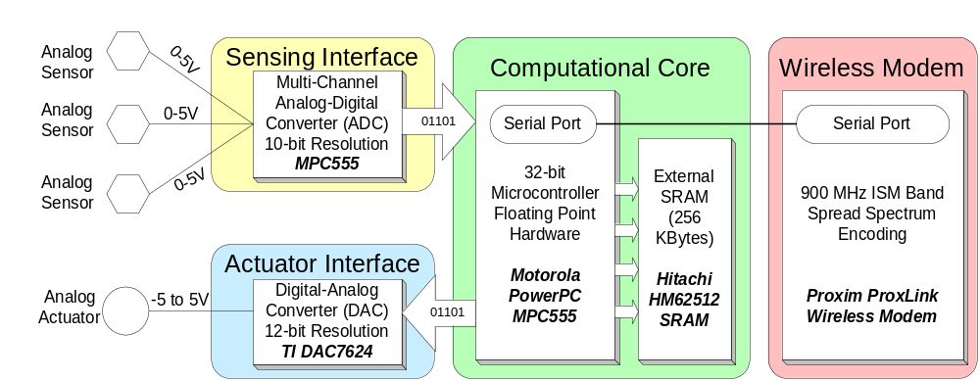

Figure 1. Architectural design of the wireless actuation and sensing unit

Computational Core

The computational core is designed to support the autonomous operations necessary for the sensing and actuation unit. Some of the key roles of the computational core include operation of sensing and actuation interfaces, management of measurement data, execution of embedded analysis procedures and control of the flow of information through the wireless modem. Among the available computational technologies such as field programmable gate arrays (FPGA) and single-board computers (SBC), embedded system microcontrollers are selected as best suited to address the tasks of the computational core. The Motorola PowerPC MPC555 microcontroller, with an internal 32-bit architecture, is chosen for the wireless actuation and sensing unit prototype design [5].
The Motorola MPC555 is a powerful microcontroller with an abundance of valuable features. Selection of the MPC555 was motivated by its high-speed internal arithmetic and logic unit. In particular, the microcontroller operates at clock frequencies as high as 40 MHz and internally integrates a floating-point unit for single-cycle floating point operation execution. The high speed of the processor is required by the high-frequency operational range of the piezoelectric elements to be connected to the unit sensing and actuation interfaces. Coupled with this fast processor is 448 Kbytes of internal read only memory (ROM) where firmware will be stored for unit operation and execution of embedded data processing algorithms. Additional features of the MPC555 utilized in the wireless actuation and sensing design are the two 16-bit general purpose input/output ports, internal time processing units (TPU) and programmable internal memory map for easy interface of additional off-chip memory. The MPC555 is programmed with software to operate at 20 MHz.
The MPC555 has 26 Kbytes of internal random access memory (RAM) that would be used for storage of temporary data generated by executing programs running from ROM and for data collected from the sensing interface. An external static RAM (SRAM) integrated circuit (IC) is added to the unit design to provide additional memory for data storage. The current prototype uses the Hitachi HM628512B SRAM IC, providing 512 Kbytes of memory storage. It should be noted that there is a performance penalty incurred for each read and write operation to the external memory. Because of slower access to external memory, data collected from the sensing interface will be temporarily placed in internal RAM. This allows the sensing interface to operate at full speed. After the data has been collected from the sensing interface, it is moved to external memory at a time when the stringent real-time constraints of the sensing interface are no longer in effect.

Sensing Interface

The on-chip analog-to-digital converter (ADC) native to the MPC555 is used as the sole sensing interface of the wireless actuation and sensing unit. The sensing interface can accommodate 32 simultaneous sensing channels with sampling rates as high as 100 kHz. However, due to the real-time demands on the unit, the MPC555 interrupt services are employed to read data on a strict timing schedule. Inherent latencies in servicing the interrupt service firmware limit the ADC to a maximum sampling rate of 40 kHz. The resolution of the analog-to-digital conversion is 10-bits but data sampled is stored as a 16-bit word. If larger ADC resolutions are desired, off-chip ADC or low-noise amplification circuits can be considered to amplify sensor outputs.

Actuation Interface

The actuation interface is responsible for providing command signals to the actuators installed within a structural system. The actuation interface is designed to output a broad range of command signals that could be used to control a large number of different actuators. At the core of the actuation interface is a digital-to-analog converter (DAC) that converts digital command signals generated by the MPC555 into analog representations acceptable for commanding the actuators. The Texas Instruments DAC7624 is selected for this task [6]. The DAC7624 accepts 12-bit digital samples in parallel and outputs a zero-order-hold (ZOH) analog signal from 0 to 5 V on four selectable channels. Using only one channel of the DAC, the settling time associated with each conversion is 10 μsec theoretically allowing digital data streams of up to 100 kHz. Because an interrupt service routine is employed in the firmware to manage the interface’s operation, the DAC is actually operated at 40 kHz.
The DAC7624 is calibrated using off-chip passive electrical components (resistors and capacitors) for minimum and maximum channel outputs of 0 and 2.5 V respectively. After the DAC makes a conversion, the output signal of the DAC is fed to an instrumentation amplifier where the signal is range shifted and amplified. An Analog Devices AD620 amplifier is chosen to shift the DAC output to a zero mean (from 1.25 V) and to amplify the signal by 4. This results in a completed actuation interface capable of outputting command voltages from -5 to +5 V using a 12-bit digital command signal issued by the MPC555.

Wireless Modem

Wireless communication is used to alleviate some of the burdens on installing and maintaining cables traditionally used in current structural monitoring systems. While a low-cost wireless communication channel is desirable, careful attention must be paid to ensure that the communication channel is reliable and can successfully propagate within civil structures over large spatial dimensions. For the wireless actuation and sensing unit, the Proxim ProxLink wireless modem is selected in this study [7]. Operating on the 902-928 MHz unregulated FCC radio band, this modem can communicate up to 300 m in open space and 150 m within civil structures constructed of heavy material such as reinforced concrete. The radio employs frequency hopping spread spectrum techniques and performs error-checking on all received wireless packets to provide a highly reliable wireless transmission channel. One inherent drawback of the ProxLink modem is its power consumption characteristics; when wirelessly transmitting and receiving, the modem draws 150 mA of current at 5 V. Due to the high power demands of wireless communications, we advocate using embedded microcontrollers to screen and consolidate information in order to minimize the use of the wireless medium [2,3]. Local data processing can lead to a reduction in the energy consumed from portable power sources, such as batteries, thereby enhancing the life expectancy of the autonomous wireless sensors.

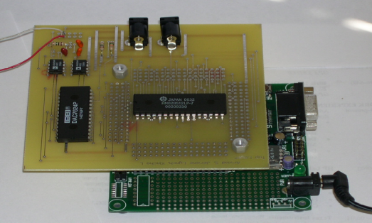
Figure 2 – A Wireless Active Sensing Unit

Wireless Actuation and Sensing Unit

To validate the proposed design, a simple prototype of the wireless actuation and sensing unit is fabricated from the hardware components chosen. The Motorola MPC555 is purchased as a small starter development kit from Axiom (PB-555) where the microcontroller is mounted on a small-footprint (8.9 cm by 8.9 cm) printed circuit board (PCB) with all port pins output as header rows. The ProxLink wireless modem is connected to the MPC555 serial port via a small DB9 serial cable. The external memory (HM628512B) and complete actuation interface circuit (including the necessary voltage regulation elements) are mounted on a small protoboard using dual-in-line package sockets. The resulting demonstration system is shown in Figure 2.

Piezoelectric Sensor and Actuator

In this demonstration study, we employ piezoelectric lead-zirconate-titanate (PZT) pads epoxy mounted to structural elements as both actuation and sensing elements. Numerous piezoelectric materials exist, both in nature (quartz) and those artificially manufactured. The piezoelectric effect refers to a material’s symmetric property of undergoing strain when an electric field is applied and generating an electric field when mechanically strained. At the molecular level, piezoelectric materials are formed of nonsymmetrical crystalline lattices with lattice charges trapped in a manner to induce natural dipoles in the matrix [8]. When mechanically strained, the lattice dipoles undergo realignment resulting in charge flowing to the material surface. Similarly, when an electric field is induced, the dipoles deform resulting in a strain in the material. With the material’s dual functionality, piezoelectrics can be used for both sensing and actuating.
Piezoelectrics have unique performance features that render them attractive for many applications. For example, at relatively low electric fields, piezoelectric materials are fairly linear and experience almost no hysteretic behavior. Another advantage is their insensitivity to temperature changes [9]. In this study, piezoelectric pads of a lead-zirconate-titanate composition, also termed PZT, is employed. The T105-A4E-602 PZT sheet with a sheet thickness of 0.191 mm is obtained from Piezo Systems, Inc., a leading manufacturer of dual-purpose piezoelectric sheets. The material and electrical properties of the T105-A4E-602 piezoelectric sheet are documented in Figure 3. The PZT sheet is nickel plated on both sides for easy soldering of electrical connections, thereby inducing an electrical field parallel to the 3rd-orthogonal direction of the pad.

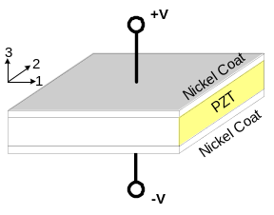
Piezoelectric Property |  |  | Value
Piezoelectric coefficient, |  | d₃₃ | 390 x 10⁻¹² m/V
 |  | d₃₁, d₃₂ | -190 x 10⁻¹² m/V
Density |  |  | 7.8 x 10⁶ g/m³
Young modulus, | E₃ |  | 5.2 x 10¹⁰ N/m²
 | E₁ |  | 6.6 x 10¹⁰ N/m²
Poisson ratio |  |  | 0.31
Thermal expansion coefficient |  |  | 4 x 10⁻⁶ /ºC
Curie temperature |  |  | 350 ºC
Figure 3. Summary of PZT Piezoelectric Material Properties [9]

VALIDATION OF THE WIRELESS SENSING AND ACTUATION UNIT

With the wireless actuation and sensing unit designed and fabricated, an experiment is devised in the laboratory to validate the performance of the fully functional wireless actuation and sensing unit. A 0.3175 cm thick aluminum bar, roughly 28.6 cm long and 6.8 cm wide, is used. Mounted to the surface of the same side of the aluminum bar are two 1.43 cm square piezoelectric pads separated by 18.9 cm. One pad is to be used as an actuator for the emission of acoustic waves along the bar’s length. The second pad will be used as a sensing unit to receive the transmitted surface waves. The piezoelectric pads will be simultaneously actuated and sensed using a single wireless actuation and sensing unit. The bar is cantilevered from a table surface to which one end of the aluminum bar is clamped. The transmitting pad will remain on the side of the table while the receiving pad will be on the cantilevered end of the bar. A picture of the laboratory setup is shown in Figure 4.
A series of excitations, as commanded by the wireless actuation and sensing unit core, are emitted by the transmitting piezoelectric pad into the aluminum element. The acoustic wave produced transverses the bar’s length and is observed by the receiving piezoelectric pad. To determine a transfer function of the piezoelectric pad-aluminum plate system that captures high frequency dynamics, the actuation and sensing interfaces will both be driven at their maximum sample rates of 40 kHz. At these high sampling rates, only internal memory can be used to store both the input and output time-history records. With only 26 Kbytes of RAM memory available on the MPC555, the amount of data that can be stored during a single validation test is limited. At 40 kHz, it is determined that approximately 8,500 data points can be comfortably stored during testing.
Ten white noise signals with standard deviations varying from 0.3 V to 1.2 V in 0.1 V increments are used for system excitation. Figure 5 presents the 1.0 V standard deviation white noise input signal and the corresponding system response recorded from the receiving piezoelectric pad. As the Lamb wave propagates across the surface of the aluminum element, the signal attenuates as seen by the reduced standard deviation of 0.4 V corresponding to the output signal.
After the excitation tests on the aluminum plate have been completed, the computational core of the wireless active sensing unit takes control of the data for post-processing. To illustrate the embedment of computational procedure for damage detection, an AR-ARX algorithm has been implemented [4]. The predicted output response of the ARX model to the white noise input with a standard deviation of 1.0 V is also shown in Figure 5. The predicted response is superimposed with the true response to illustrate the model residual error. As shown, the ARX model calculated closely predicts the output response of the piezoelectric pad-aluminum system when excited by a white noise excitation with standard deviation of 1.0 V.

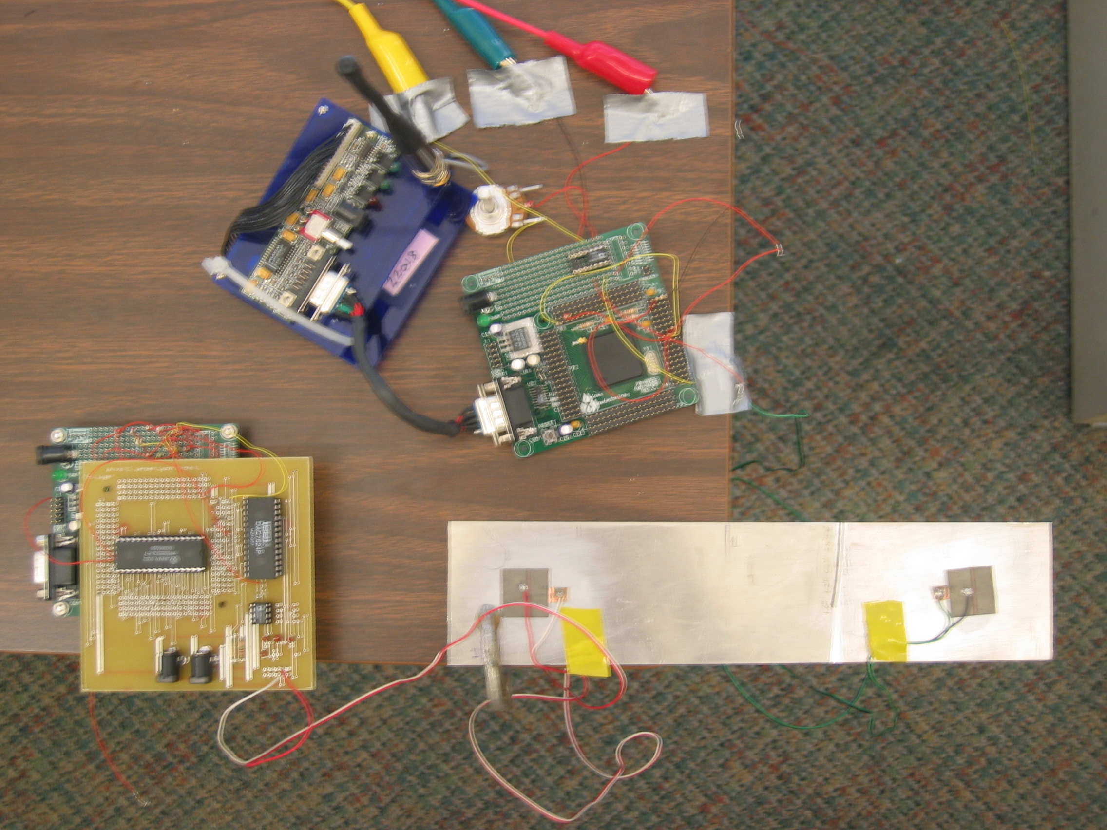
Wireless Modem (Serial Link)
Signal Amplifier (Variable Gain)
Sensing Unit W/ on board A/D(10Bits)
Test Bar
Sensing Piezo Pad
Actuating Piezo Pad
Actuating Unit
SRAM
DAC (12 bit)

Figure 4. Laboratory setup of the cantilevered aluminum bar

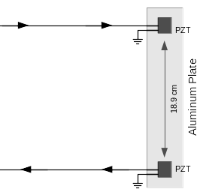
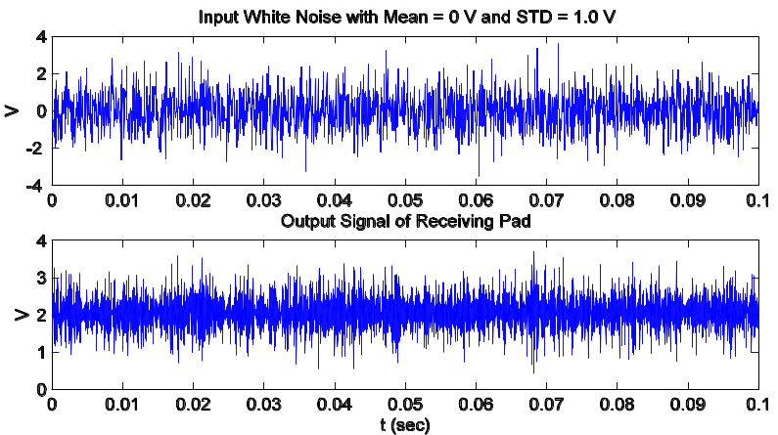
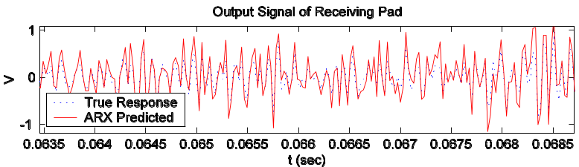

Figure 5. Input white noise, recorded output response and predicted response using the ARX model

CONCLUSION

To reduce installation costs and enhance functionality, innovative technologies are currently being adopted in structural monitoring systems. This study has explored the feasibility to include an actuation interface in a wireless sensing unit design. Capable of commanding structural actuators, the resulting wireless active sensing unit can enjoy a direct interface to the physical system in which it is installed. The proposed wireless active sensing unit is capable of recording response measurements resulting from the unit’s own action. Hence, the sensor is no longer a passive but an active sensor which can actuate an excitation on a structural element upon demand. To illustrate the performance of the prototype wireless active sensing unit, an aluminum plate with two PZT piezoelectric pads epoxy mounted to its surface is employed. With white noise excitations generated on one pad, the unit simultaneously records the response of the second piezoelectric pad. After collection of the system response, the computational core is utilized to calculate an ARX time-series model for the input-output measurement data. As illustrated, the ARX model determined by the computational core is sufficiently accurate to provide good prediction of the true output response. This simple but non-trivial experiment has demonstrated the possibility of developing a self-actuated wireless sensing unit with great potential to address structural self-diagnostic applications.

ACKNOWLEDGEMENTS

This research is partially sponsored by Los Alamos National Laboratory, Contract Number 75067-001-03. This research is also supported by the National Science Foundation, Grant Numbers CMS-9988909 and CMS-0121842.

REFERENCES

- Straser, E. G., and Kiremidjian, A. S. (1998). A modular, wireless damage monitoring system for structures. Report No. 128, John A. Blume Earthquake Engineering Center, Department of Civil and Environmental Engineering, Stanford University, Stanford, CA.
- Lynch, J. P., Sundararajan, A., Law, K. H., Kiremidjian, A. S., and Carryer, E. (2003a). “Power-efficient data management for a wireless structural monitoring system.” Proceedings of the 4th International Workshop on Structural Health Monitoring, Stanford University, Stanford, CA, in press.
- Lynch, J. P., Sundararajan, A., Law, K. H., Kiremidjian, A. S., Kenny, T. W. and Carryer, E. (2003b). “Embedment of structural monitoring algorithms in a wireless sensing unit.” Structural Engineering and Mechanics, Techno Press, 15(3): 285-297.
- Sohn, H., and Farrar, C. R. (2001). “Damage diagnosis using time series analysis of vibration signals.” Smart Materials and Structures, Institute of Physics, 10(2001):446-451.
- Motorola (2000). Motorola PowerPC MPC555 user’s manual. Motorola Corporation, Phoenix, AZ.
- Burr-Brown (1997). DAC7624 data sheet: 12-bit quad voltage output digital-to-analog converter. Burr-Brown Corporation, Tucson, AZ.
- Proxim (1994). ProxLink PL and PL2 radio modem family user’s manual. Proxim Corporation, Mountain View, CA.
- Janocha, H. (1999). Adaptronics and smart structure. Springer-Verlag, Berlin, Germany.
- Banks, H. T., Smith, R. C., and Wang, Y. (1996). Smart material structures: modeling, estimation and control. John Wiley & Sons, New York, NY.
- Piezo Systems (2003). Introduction to piezo transducers. Piezo Systems, Inc., Cambridge, MA.

